AI ASSISTED CODING
NAME: N.RUKMINI
ENROLL NUMBER: 2403A52402
BATCH NUMBER :14

Lab assignment-11.4

Task 1: Implementing a Stack (LIFO)
- Task: Use AI to help implement a Stack class in Python with the following operations: push(), pop(), peek(), and is_empty().
- Instructions:
  - Ask AI to generate code skeleton with docstrings.
  - Test stack operations using sample data.
  - Request AI to suggest optimizations or alternative implementations (e.g., using collections.deque).
Code:
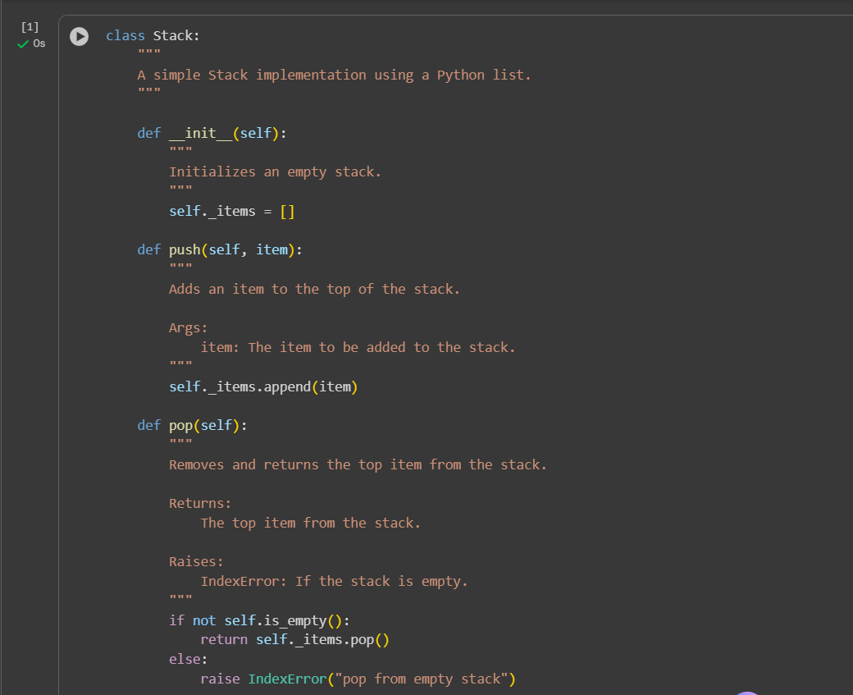
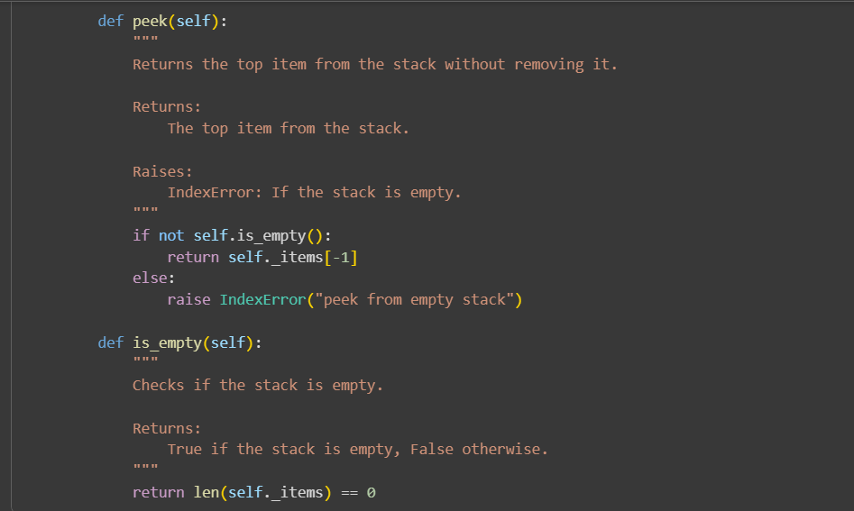
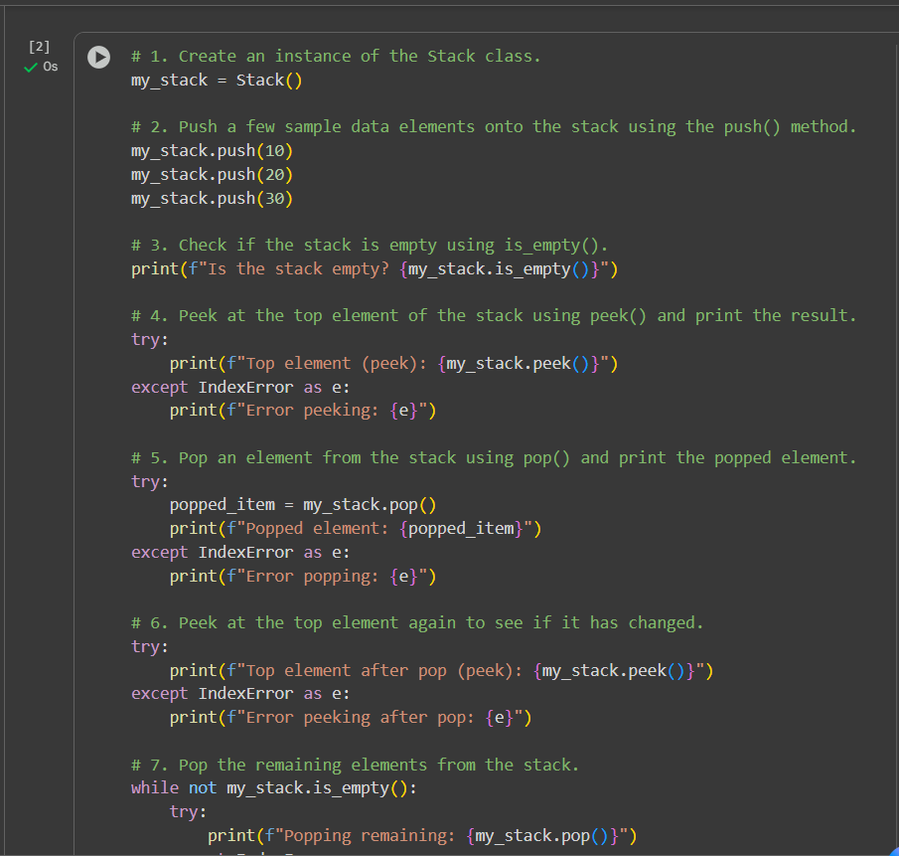
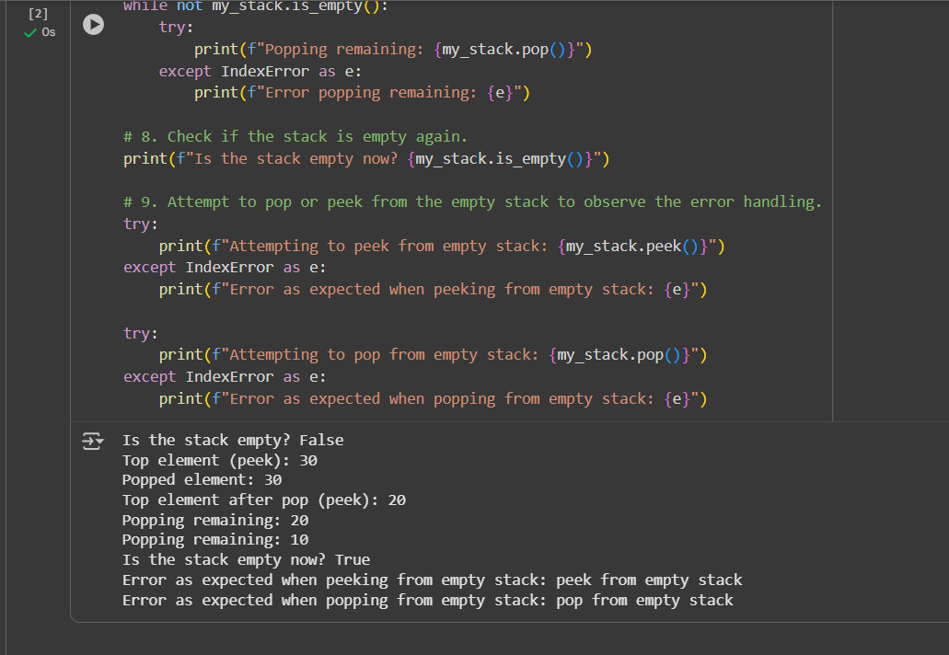
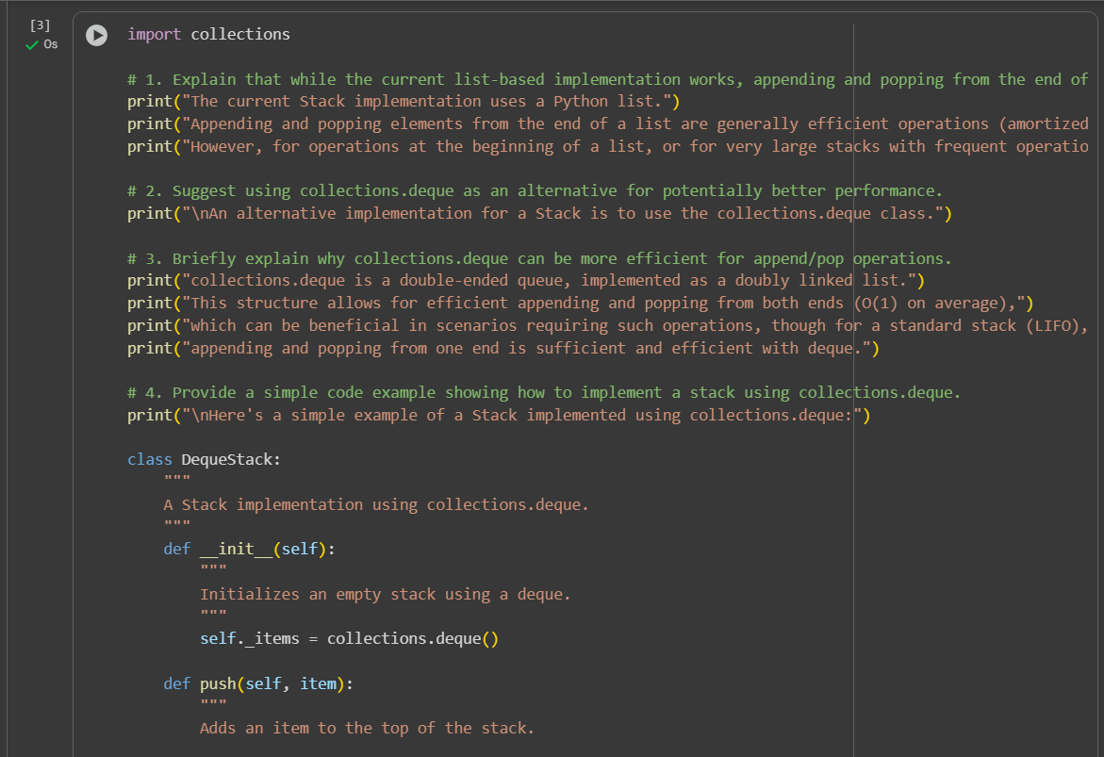
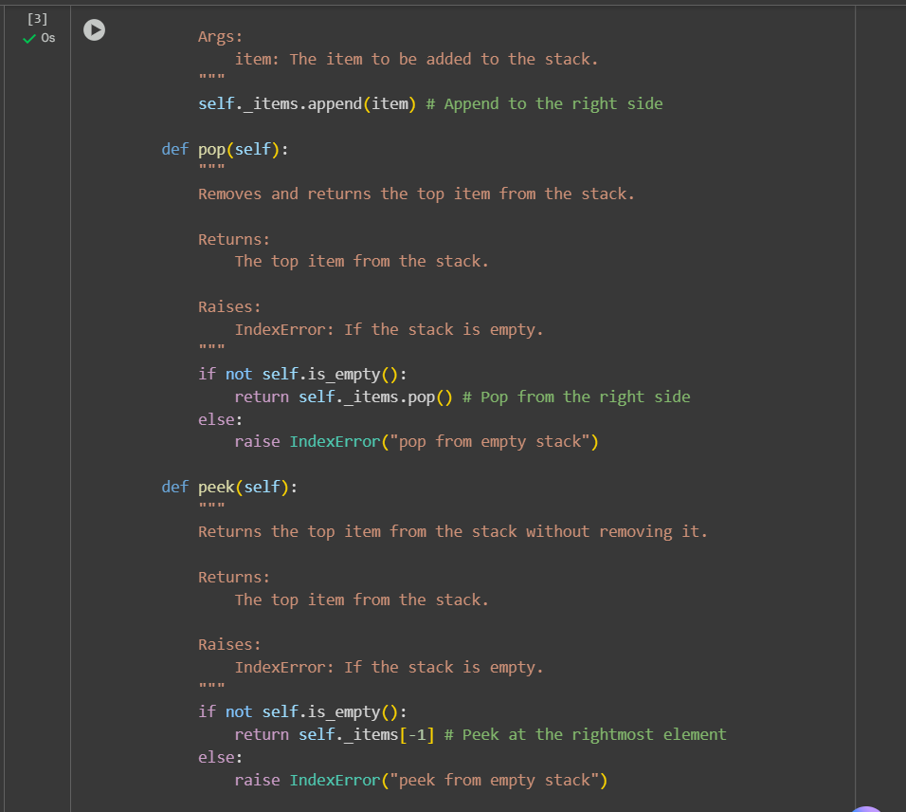
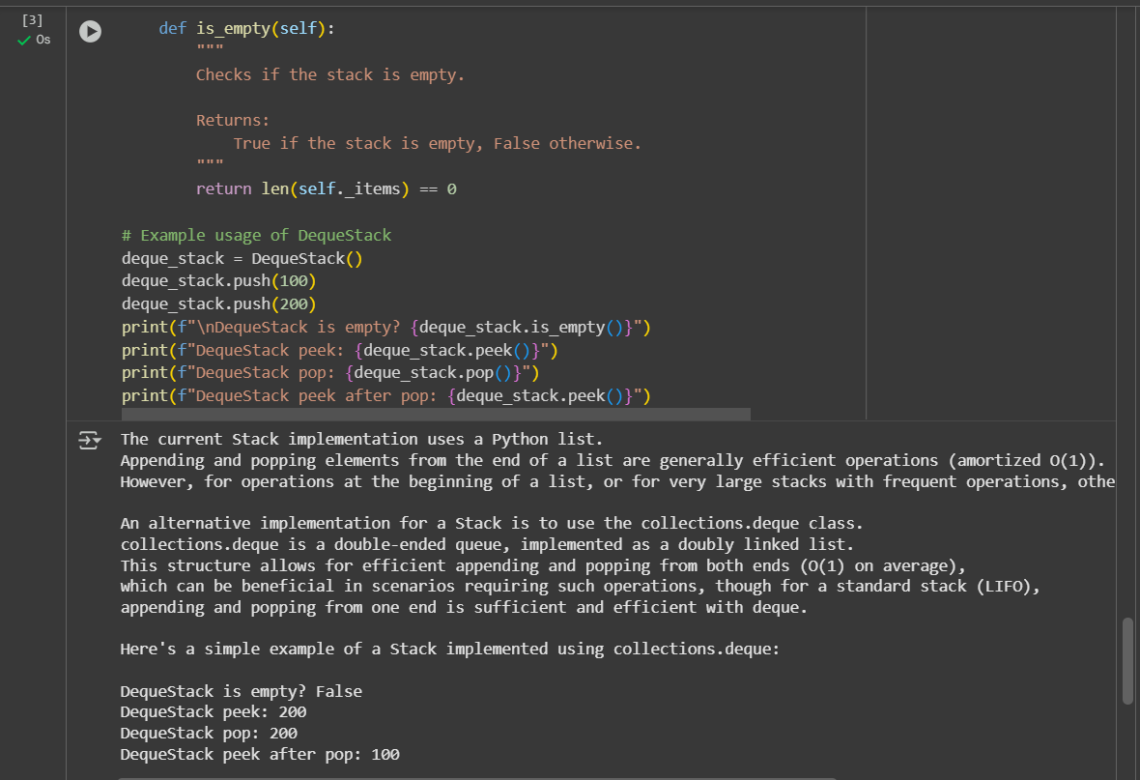

## Summary:

### Data Analysis Key Findings

* A Python class `Stack` was successfully implemented using a standard Python list (`self._items`) to store elements.
* The `push()` method appends elements to the end of the list, `pop()` removes and returns the last element, and `peek()` returns the last element without removing it.
* The `is_empty()` method correctly checks if the internal list is empty.
* Error handling for `pop()` and `peek()` on an empty stack was implemented using `IndexError`.
* Testing confirmed that `push()`, `pop()`, `peek()`, and `is_empty()` methods function as expected, including the error handling for empty stacks.
* An alternative `DequeStack` class using `collections.deque` was presented, demonstrating an alternative implementation that also provides efficient O(1) operations for stack functionality.

### Insights or Next Steps

* The list-based stack implementation is generally efficient for typical stack operations.
* For scenarios requiring high performance with very large stacks or potential extensions involving operations on both ends, `collections.deque` offers a potentially more performant alternative.

Task 2: Queue Implementation with Performance Review
• Task: Implement a Queue with enqueue(), dequeue(), and is_empty() methods.
• Instructions:
o First, implement using Python lists.
o Then, ask AI to review performance and suggest a more efficient implementation (using collections.deque).

code:
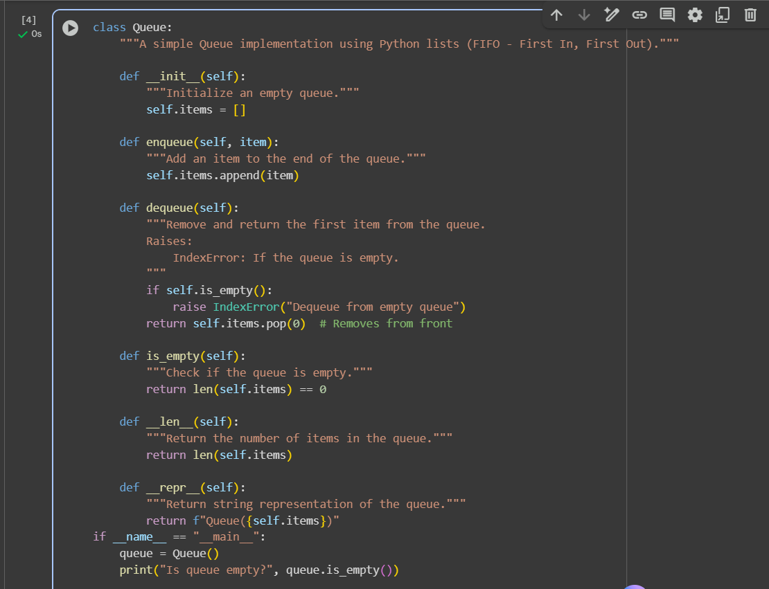
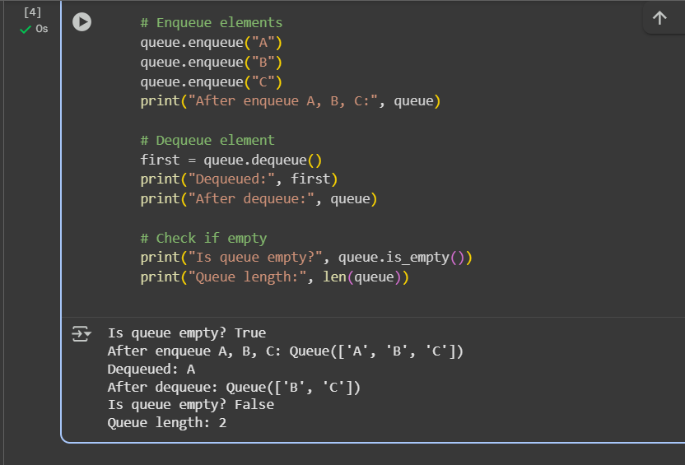

Task 3: Singly Linked List with Traversal
• Task: Implement a Singly Linked List with operations: insert_at_end(), delete_value(), and traverse().
• Instructions:
o Start with a simple class-based implementation (Node, LinkedList).
o Use AI to generate inline comments explaining pointer updates (which are non-trivial).
o Ask AI to suggest test cases to validate all operations.

Code:
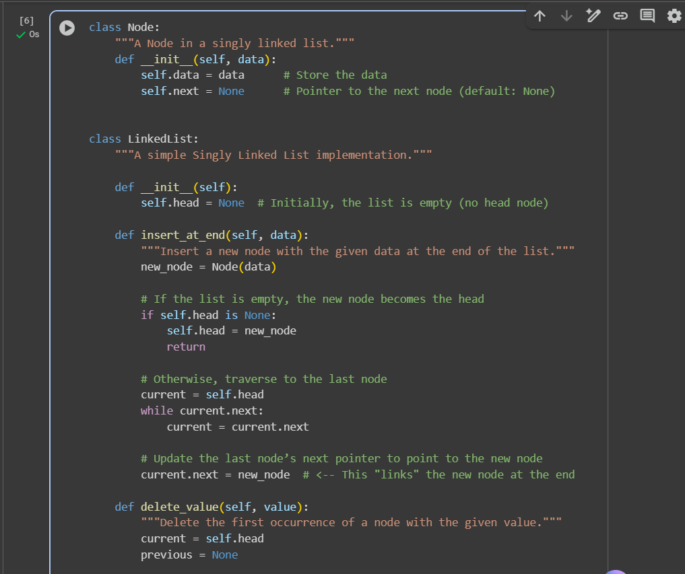
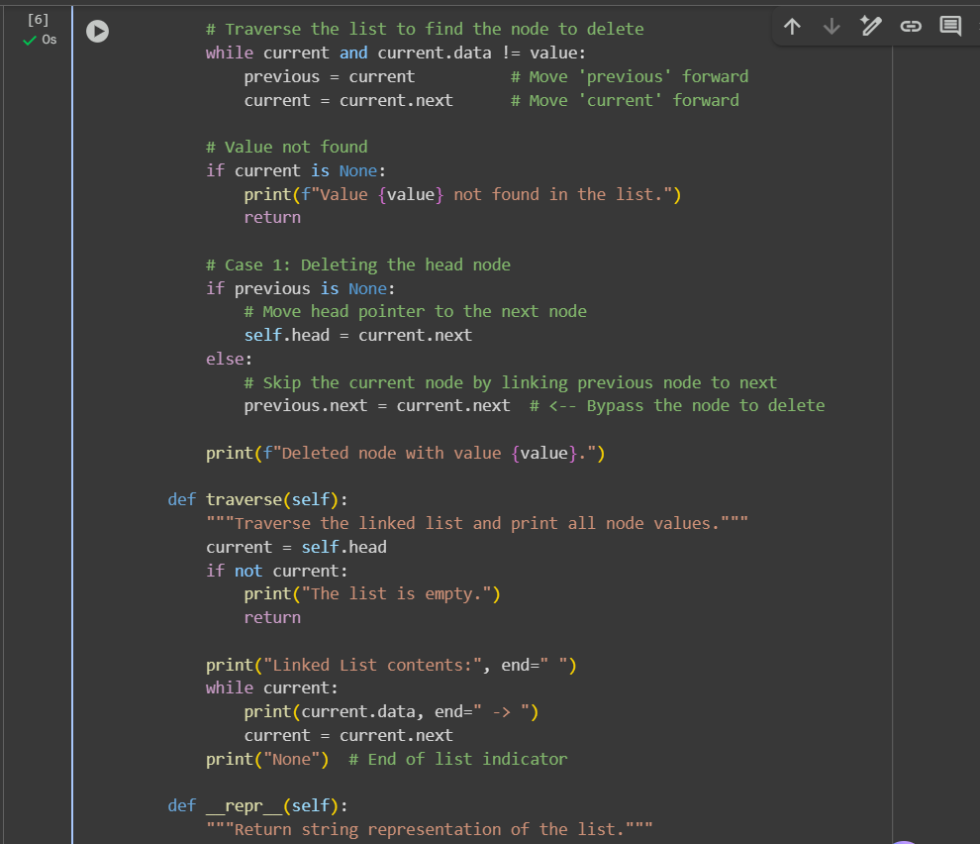
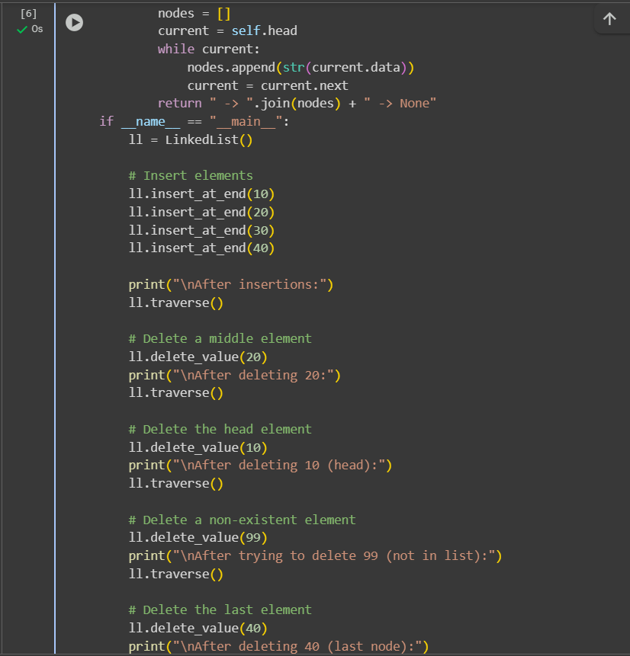

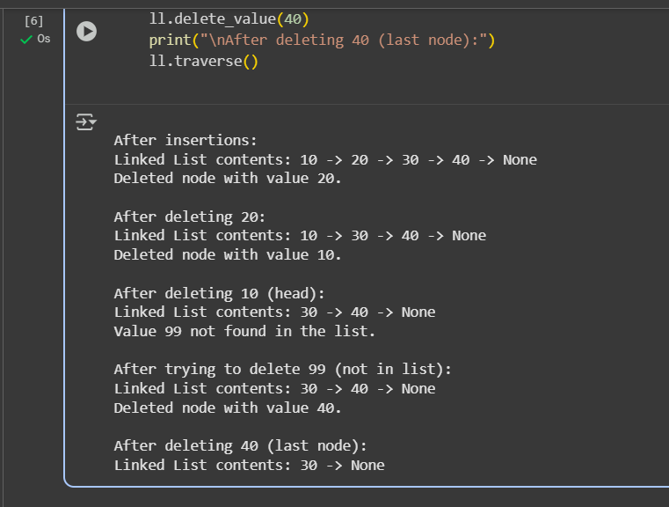

Task 4: Binary Search Tree (BST)
- Task: Implement a Binary Search Tree with methods for insert(), search(), and inorder_traversal().
- Instructions:
  - Provide AI with a partially written Node and BST class.
  - Ask AI to complete missing methods and add docstrings.
  - Test with a list of integers and compare outputs of search() for present vs absent elements.
- Expected Output:
- 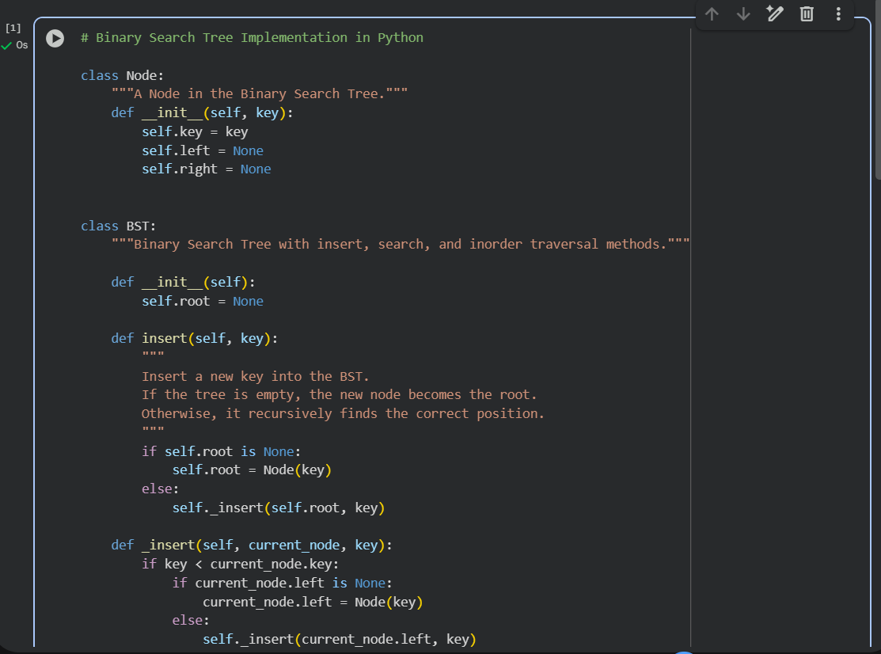
- 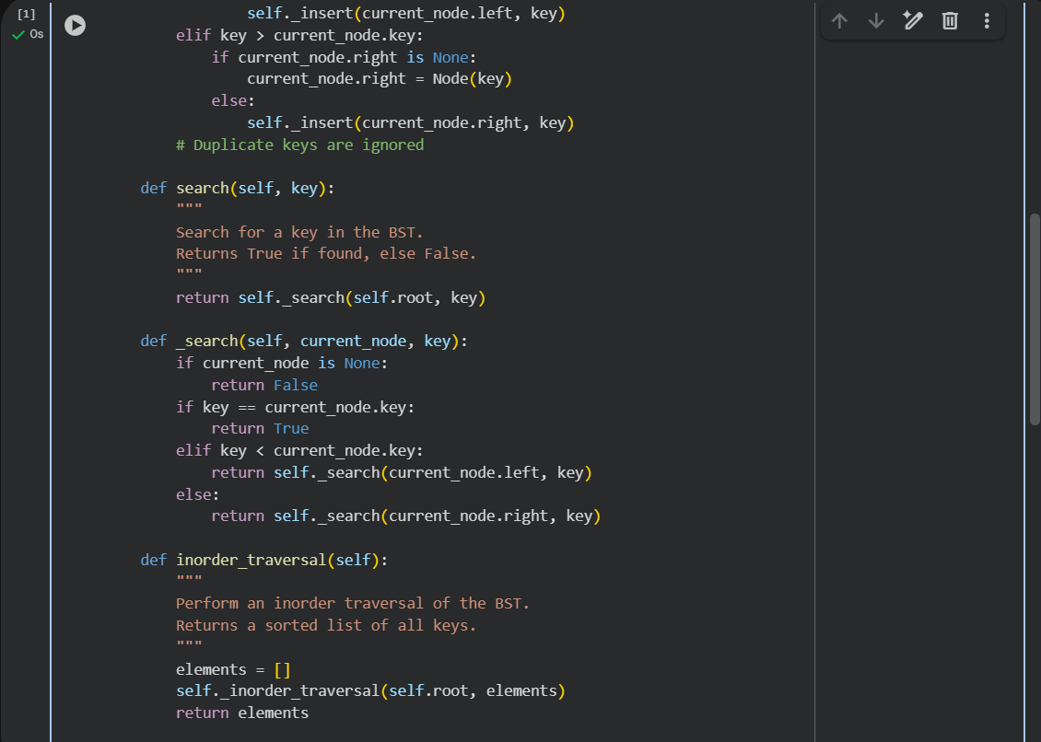
- 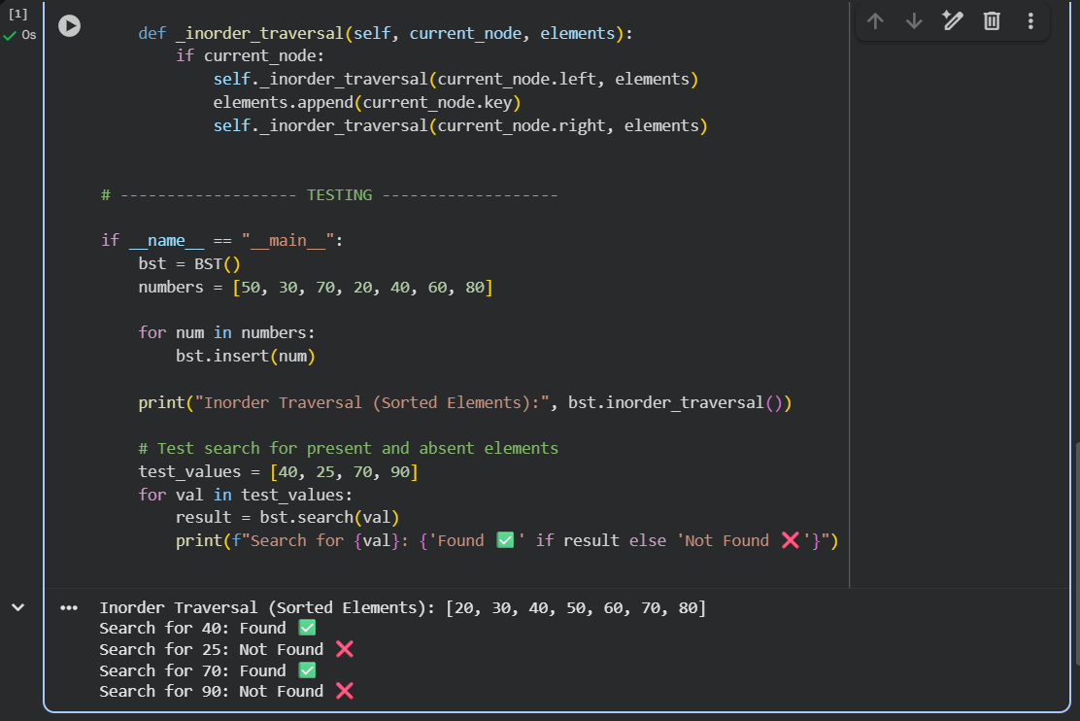
Task 5: Graph Representation and BFS/DFS Traversal
- Task: Implement a Graph using an adjacency list, with traversal methods BFS() and DFS().
- Instructions:
  - Start with an adjacency list dictionary.
  - Ask AI to generate BFS and DFS implementations with inline comments.
  - Compare recursive vs iterative DFS if suggested by AI.
